
Briefing Package 2022



Contents
Welcome To Kootenay Lake Fire Zone! 3
Initial Attack Procedures 4
Southeast Fire Centre Alert Levels & Standby 4
Level Of Alert: 4
Standby Hours 5
Fireline Expectations 6
Finance & Administration 8
Finance & Admin Forms 8
Resource Requesting Procedures/Expectations 8
Kootenay Lake Fire Zone Org Chart 9
Kootenay Lake Fire Zone Contact Info 10
Kootenay Lake Base – General Info 11
Fuel & Equipment Caches 12
Zone Systems & Printers 12
Orientation Tools (Maps, GPS Setup & Declination) 13
Weather Stations & Briefings 14
Ferry Considerations 16
Fire Wardens 17
Reporting Relationships – Line of Authorty & Site Support Level 17
Fire Centre Operations 17
MZOC – Ministry Zone Operations Centre 17
Safety 19
Cross Border Checklist 21

Welcome to Kootenay Lake Fire Zone!
The Kootenay Lake Forest District landscape is dominated by steep rugged mountains with fast-flowing rivers and long narrow lakes lying in narrow forested valleys. There are two mountain ranges in the Kootenay Lake Fire Zone, the Purcell Mountains east of Kootenay Lake, and the Selkirk Mountains west of Kootenay Lake. The Kootenay Lake Forest District is in the interior wet belt and receives precipitation levels second only to those of the B.C. west coast. The climate is continental, with moderate winters and warm summers. The alpine meadows and subalpine forests are snow free from mid-July through mid-October; adverse weather can be expected year-round in these higher elevations.
Road access to the area is provided by Highway 3 from the east and west, and by Highway 6 and 31 from the north. Highways 6, 21, and 22 provide access from the south. The Kootenay Lake Fire Zone is over 1.2 million hectares in size and stretches from the northern end of the Duncan River to the US border south of Creston. The Zone includes the cities of Nelson and Creston and several smaller communities throughout the region.
Wildfire Management for the district is provided by the Kootenay Lake Zone office located adjacent to the District office. The zone office manages all values within these administrative boards and averages 100 incidents per year.
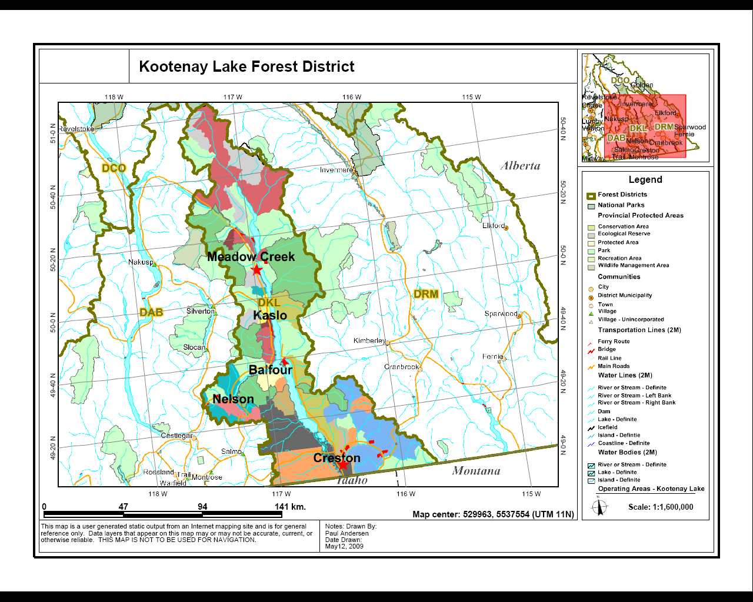

Initial Attack Procedures

- Follow all safe work procedures
- Be sure to keep the SEFC up to date regarding incident size, fire behaviour, fire status, ET, resources on site, containment difficulties, hazards and issues, Wx, objectives and plans for current and next operational period
- Be sure to request additional resources when needed (or a Fire Officer if necessary)
- Be prepared to overnight fires when necessary
- Be aware of grounding time and shut down hazardous activities prior to losing medical evacuation capabilities
- Always get a clear 8-hour break, or seek ZWCO approval to forgo a clear 8
- Local crews generally utilize webbing and carabiners to facilitate slinging operations; please request a net with your helicopter if you require one - you may be able to sign one out from the warehouse
- Fire reports are completed electronically via Wildfire One on the Ministry’s web page and recorded on the Incident drive

SOUTHEAST FIRE CENTRE Alert Levels & Standby

Level of Alert:
The posted alerts indicate the maximum acceptable time period for crew mobilization, whether it is for dispatch to a fire or base change. Crews must understand and confirm their standby requirements with the ZWCO.

RED ALERT: Crews must be ready to depart from a pre-determined staging point/in a helicopter immediately upon a fire call.
YELLOW ALERT: Crews must be ready to depart from a pre-determined staging point within 30 minutes from the time of the fire call.
BLUE ALERT: Crews must be ready to depart from a pre-determined staging point within a specified time longer than 30 minutes.
(e.g.: BLUE 1: dispatch within one hour, BLUE 2: within two hours, etc.)
GREEN ALERT: Crews are on "stand down" or deployed to other projects.

The levels of alert are included on the Daily Fire Report each morning. When crews are working out of a specific Fire Centre, the Fire Centre will inform the crew of the alerts. Air tankers and bird dog aircraft are coordinated through the central air tanker dispatch centre, Kamloops.

Standby Hours
Hours of operation for SEFC Regional Wildfire Coordination Centre (RWCC) when alerted to standby is 08:00-16:00 locally for all Officers. One-hour lunches are expected when alerted to standby. Standby is set on Thursday and reconfirmed/uplifted Mondays.

MINIMUM STANDBY (mins): On Thursday PM, Officers and crews starting 08:00 will have a 6-hour standby block at end of shift. On Friday AM, crews starting 10:30 will have standby starting Friday AM at designated start time (08:00) and the second portion of their standby block to follow their shift.

Officers on 08:00 - 16:00 work schedule:
16:00 - 22:00 weekdays, 09:00 - 21:00 weekends.

Crews on 08:00 - 16:00 work schedule:
16:00 - 22:00 weekdays, 09:00 - 21:00 weekends.

Crews on 10:30 - 18:30 work schedule:
08:00 -10:30 and 18:30 - 22:00 weekdays, 09:00 - 21:00 weekends.

Additional requirements set on Monday will start 08:00 on Tuesday, and end 22:00 on Thursday.

MODIFIED STANDBY (mods): Any hours set by the RWCO, between minimum and maximum standby (lunch standby should be considered / will be required depending on intensity level).

MAXIMUM STANDBY (max): 24 hours less working time.

Fireline Expectations

Point of Origin
Points of origin on suspicious fires must be preserved for investigations. Please flag off POIs and DO NOT disturb the area by any means. Do not walk in/around this area, do not drive, drag hose, or spray water in this area. This will involve controlling the fire, yet leaving the fire burning around the POI until instructed otherwise by the ZWCO.
Communication
It is preferred that the IC communicate updates/requests over the radio to ensure everyone is kept informed. Communicating via repeater allows dispatch, ops, ZWCO, and all crews to hear updates simultaneously. Unless the repeater is tied up, please reserve the use of cell phones for long/detailed conversations.
All vehicles are equipped with SEFC repeater maps and radio instructions including local FSR frequencies. Kootenay Lake Fire Zone operates on Tone 5.

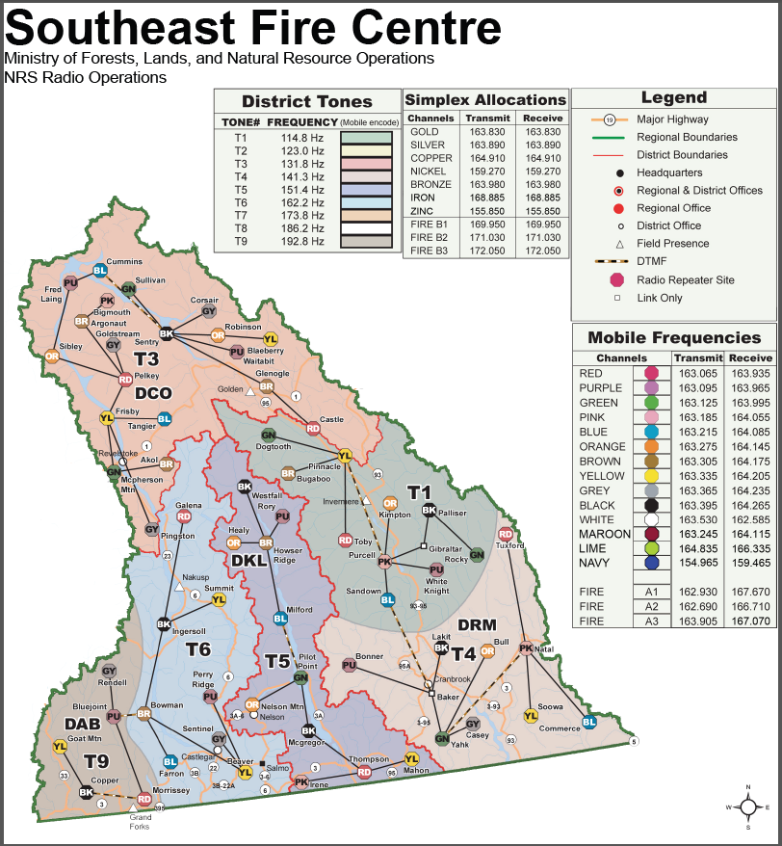

Daily Estimated Cost (DEC) Reporting
All crews must report the required information for completing Daily Estimated Costs (DEC) to their IC.
*Submit any costs daily to ZWCO for Wildfire Costing Report.

Finance & AdminISTRATION

Finance & Admin Forms
The following forms are required if you are the IC on a fire:
- Initial Fire Report (FS260) – call into the Fire Centre on arrival at fire and updated as required.
- Electronic Final Fire Report – digital versions with photos and scanned IC notes are to be entered on the Incident Drive and a Wildfire One fire report should be completed before departing the Zone.
- FS17 – required if you leave equipment on an incident.
- Smoke chase/Nuisance reports – called in to the Fire Centre on arrival at a fire and updated as required.

The following are required by all crews/officers:
- eDiaries – should be filled out daily and preferably signed off with supervisor approval weekly. A copy may be requested by the zone or Fire Centre.
- Purchase card expenditures – a copy of all expenses charged to a fire must be submitted to the fire zone or MZOC office daily (required for DEC and Final Wildfire Report)

It is expected that all Admin/Fire reports will be 100% completed/submitted/signed before your departure. Please use any down time to keep organized.

Resource Requesting Procedures/Expectations
Any resource requests must be relayed through the ZWCO. Factors to consider:

- Resourcing for 4hrs to 1 day in advance
- Having your resources arrive before crews
- Staging areas/long-term planning
- Travel time/meals/breaks for crews/clearing 8

Contact the ZWCO once you release any resources, so they know what is currently available.

KOOTENAY LAKE FIRE ZONE ORG CHART

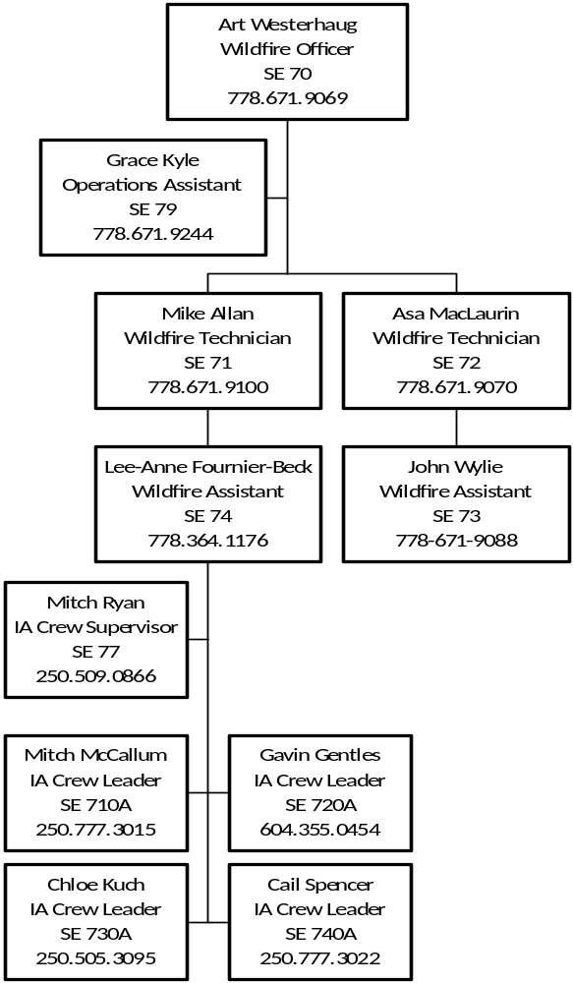

KOOTENAY LAKE FIRE ZONE CONTACT INFO

Zone phone: 778-671-9244
ZWCO desk: 778-671-9243
Fax: 250-825-4081
SE Fire Centre: 250-365-4040

Mailing: Kootenay Lake Fire Zone
1907 Ridgewood Road
Nelson, BC
V1L 6K1

Physical Location: Highway 3A, 4 miles north of Nelson on the main floor of the Kootenay Lake Forest District office.

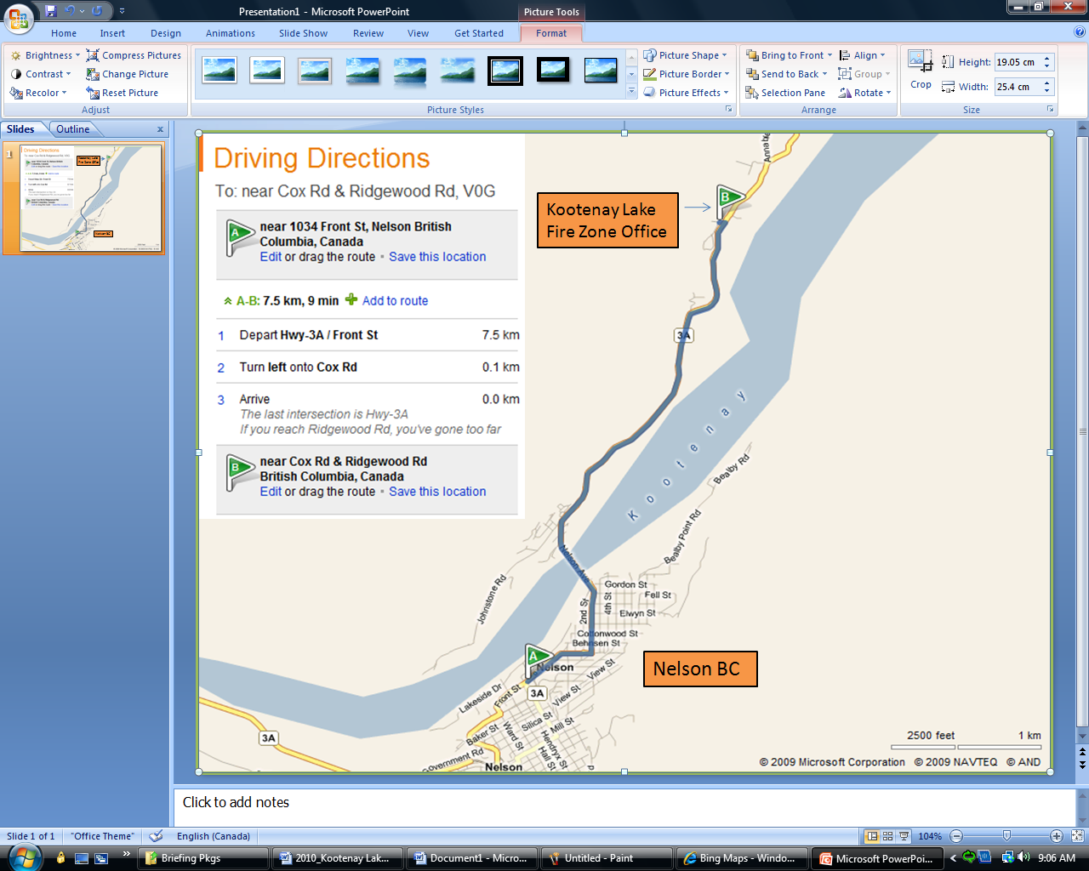

KOOTENAY LAKE BASE – GENERAL INFO

Kootenay Lake Zone Access

You may be assigned a set of keys as listed below, access into the Zone office and IA office requires an electronic key (FOB). Please do not lose these keys as the entire facility will need to have the locks redone if keys are unaccounted for. Please call the zone RO if you need access to our facilities after hours if keys are not issued to you.

The keys are engraved with the following marks for identification purposes.

“G” Key – access through the compound gate into the upper parking lot
“FOB” – access into main BCWS office
“P” Key – access to warehouse/ Fuel room and IA ready room
“3303” Key – fuel caches

Lockup Procedures
If you are the last to leave base, the following procedures should be followed:

- All equipment to be put away and general clean around the base, please recycle bottles and keep lids on garbage containers
- All electrical appliances are turned off (Coffee Pots, Electrical Tools)
- All windows need to be locked
- All Doors need to be locked (Fuel sheds, Warehouses, Crew Ready Rooms, “C” cans and Garden Sheds)
- Lights turned off
- Lock main compound gate

Please ensure you are briefed on current alarm codes to activate the alarm when leaving.

Parking
All vehicles are to be backed in. Visitor parking is available in the main parking lot on the outside of compound gate or vehicles can be parked on the upper tier parking lot inside the compound gate.

Warehouse & Gear
You will need to get permission from the local Zone Wildfire Coordinating Officer before removing anything significant from the warehouses.
- A FS17 will be filled out when signing out or returning equipment.
- A Field FS17 will be required when you are leaving equipment in another zone or receive equipment from another zone
The appropriate zone staff member will enter this information into IMIS

If you require special equipment or we do not have certain items that you need to do your job, please ask the ZWCO and we will do our best to get if for you.

FUEL & EQUIPMENT CACHES

The fuel caches can be accessed with a 3303 key. Please use an FS17 when signing out gear and update the ZWCO what has been removed so it can be re-stocked.

NAME | TYPE | LAT | LONG
Lardeau | Fuel/Equipment  **No Mediums** | 50 08.750 | 116 57.150
Creston | Commercial Fueling Equipment | 49 02.252 | 116 29.773
Kaslo | Fuel Jet A | 49 59.130 | 116 56.070
Nelson | Commercial fueling | 49 29.650 | 117 18.030
Kootenay Bay Ferry Landing | Equipment Fuel Only (24:1/50:1)  3’X5’ Aluminum Box 3303 Key | 49 40.510 | 116 52.360

ZONE SYSTEMS & PRINTERS

Local drive information available (IDIR access)
If you require access to our local G:\drive a request must go through the local Zone Officer to our systems representative and he will supply instructions.
Shawn.Anderson@gov.bc.ca Office: 250-365-4057 Cell: 250-304-9406

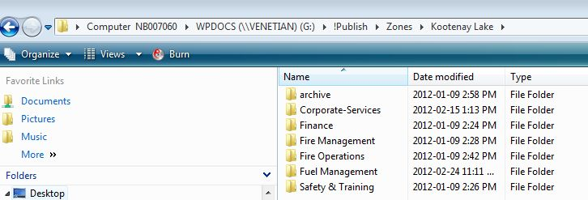

While accessing our local drive - Please be careful not to delete or change information that you are not authorized to do. We appreciate it if you only access the folder(s) that you need to complete your work while supporting our zone.
Folders of note:
- G:\!Publish\Fire-Operations\Plans\OSWS 2 Tracker
- G:\!Publish\Fire-Operations\Plans\Manifests
- G:\!Publish\PreOrg\N7 Kootenay Lake\Pre-Org Manual
- G:\!Publish\PreOrg\N7 Kootenay Lake\Zone Briefing Package

Wifi Networks
BCNGN – Log in using your IDIR account and password
DOGWOOD – No password, guest access

Printers
To print a document, you can use the following printers located in our office:

HP LaserJet Enterprise M605 – located behind OA desk
P11711 on Glacier (\\Glacier\P11711)

HP Desk Jet 5550 series PCL6 – located in the room adjacent to forestry office on main floor
(\\Hippo\PullPrint) or (\\Hippo\PullPrintPS)

ORIENTATION TOOLS (MAPS, GPS SETUP & DECLINATION)


Please ensure you have a West Kootenay Backroads Mapbook to orient yourself to the zone.

If you are not provided with a Backroads Mapbook, they can be purchased at local visitor centres. In addition, use the QR code to the right to download the georeferenced BC Provincial Repeater Map to Avenza. Avenza is a tool to download maps for offline use, and is available on the App store.

GPS Garmin Legend Setup
Time: 24-hour, Pacific Time Zone
Display: 15 seconds Interface: Garmin
Units: hddd mm.mmm’ NAD83: Metric, Meters, m/min
Headings: Degrees, True System: Normal, WAAS Enabled

Calculated Magnetic Declination for Kootenay Lake, BC
Year: 2015 | Latitude: 49° 28’60” North | Longitude: 117° 16’60” West
Calculated magnetic declination: 15° East

WEATHER STATIONS & briefings

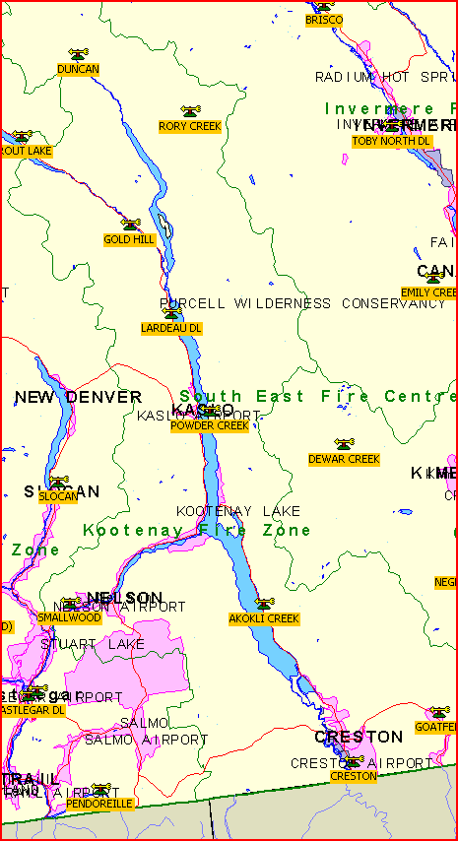

A complete list and description of all SEFC weather stations can be found here.

SEFC Preparedness/Weather Briefing Calls
Dial 1-888-952-9304, Conference ID 7712305
Time: Monday and Thursday mornings at 0915 Pacific/1015 Mountain
Schedule:
- SEFC Plans Officer completes roll call for zones and other agencies
- Meteorologist starts Wx briefing
- FBAN provides information (if any)
- All other section chiefs provide their input (RWCO, OPS, AIR, PLANS, LOGS)
- Any other information that pertains to safety, bans, FAS, Smoke issues etc... are discussed
- Start zone roll call – Kootenay lake is 6th on the list – provide zone updates
  - Only have a few minutes for each zone. Cover the main issues & concerns and a quick snapshot of incidents.
- Fire Centre Manager provides comments
- Final call then next conference is discussed

To view the region’s most recent weather briefing:
https://bcfireweatherp1.nrs.gov.bc.ca/scripts/menu/BC/ShowPage.asp?page=wxbrief

FERRY CONSIDERATIONS

Crews may be required to cross Kootenay Lake using the Kootenay Lake Ferry. Due to TDG requirements, crews are only allowed to travel across the ferry with one 5 Gal (22L) can of fuel per truck.

If you find yourself on the Balfour side exceeding this amount of fuel, you can temporarily store your fuel in the gated compound adjacent to the Gill and Gift gas station at the ferry landing. If this gate is locked, ask the gas station attendant to open it for you.

Kootenay Lake Ferry
Route: Across Kootenay Lake from Balfour to Kootenay Bay, 25km NE of Kootenay Lake base on highway 3A
Crossing time ~40 minutes, schedule below. All times in PST.
Vessel name | Departing Balfour Terminal |  | Departing Kootenay Bay Terminal
 | Summer | Winter | Summer | Winter
Osprey 2000 | 6:30 am | 6:30 am | 7:10 am | 7:10 am
Osprey 2000 | 8:10 am | 8:10 am | 9:00 am | 9:00 am
Osprey 2000 | 9:50 am | 9:50 am | 10:40 am | 10:40 am
M.V. Balfour | 10:40 am |  | 11:30 am
Osprey 2000 | 11:30 am | 11:30 am | 12:20 pm | 12:20 pm
M.V. Balfour | 12:20 pm |  | 1:10 pm
Osprey 2000 | 1:10 pm | 1:10 pm | 2:00 pm | 2:00 pm
M.V. Balfour | 2:00 pm |  | 2:50 pm
Osprey 2000 | 2:50 pm | 2:50 pm | 3:40 pm | 3:40 pm
M.V. Balfour | 3:40 pm |  | 4:30 pm
Osprey 2000 | 4:30 pm | 4:30 pm | 5:20 pm | 5:20 pm
M.V. Balfour | 5:20 pm |  | 6:10 pm
Osprey 2000 | 6:10 pm | 6:10 pm | 7:00 pm | 7:00 pm
Osprey 2000 | 7:50 pm | 7:50 pm | 8:40 pm | 8:40 pm
Osprey 2000 | 9:40 pm | 9:40 pm | 10:20 pm | 10:20 pm
Summer schedule runs from the third week of June through Labour Day.

Schedule information: 250-229-4215
General inquiries: 250-229-5650
Emergency 24h number: 250-354-7658 (Bryan Coe – Regional Marine Manager)
Fax: 250-229-5679
M.V. Balfour vessel phone: 250-354-7650
Osprey 2000 vessel phone: 250-354-7656

Harrop Cable Ferry
Route: Across Kootenay Lake from Hwy 3A to Harrop/Procter communities, 18km NE of Kootenay Lake base
Crossing time ~5 minutes, hours on demand 0545 to 0015

Phone: 250-229-5650 or Highways Radio Channel 2
Fax: 250-229-5679

Fire Wardens

Name | Call sign | Location | Contact info
Merle Bredt | 71B | Creston | 428-2688
Nick Green | 71D | Argenta | 225-3597 | 236-972-6202
Greg Munch | 71E | Nelson | 354-5370 | 354-5323
Don Dalton | 71F | Yahk | 424-5274 | 919-1974
Jim Brodie | 71G | Meadow Creek | lookoutjim2@gmail.com

REPORTING RELATIONSHIPS – LINE OF AUTHORITY & SITE SUPPORT LEVEL

Fire Centre Operations
If assigned to the Fire Centre organization your supervisors and reporting relationships will be covered in your initial briefings.

MZOC – Ministry Zone Operations Centre
FLNRO’s site support EOC/DOC primarily for wildfire response operated by BCWS.

An MZOC is activated as required for a specific geographic area with authority from RWCC. There are 3 levels of MZOC that may be activated depending on need and role:
- Type 3 – expanded logistics support
- Type 2 – coordination and assignment of specific resources and/or specific functions
- Type 1 – full coordination, dispatch and use of assigned resources operating similarly to the RWCC but continuing to report to RWCC

ZONE – MZOC III (normal fire operations)
All fire activity will be directed by SEFC Fire Operations. The local Fire Zone is responsible for zone level logistical support. The Zones may require specific updates depending on conditions. Your Zone contact will brief you on your role.

ZONE – MZOC I or II (increased fire activity)
This level must be initiated by the FCO and a signed MZOC Delegation of Authority letter given to the MZOC Director. Functional responsibilities and reporting relationships will be spelled out in this document and all staff must be briefed on its contents.

Crew Rotation and Assignments
The crew rotation schedule has been set for the season; it will be up to the MZOC director or ZWCO to fit you into this rotation. Your assignments will also be given to you by the local base officer.

WCO – Wildfire Coordination Officer has a mandate to act in anticipation of fire problems as well as to coordinate all fire control resources at their disposal within their jurisdiction.

RWCO – Regional Wildfire Coordination Officer sets fire control priorities within the centre, controls the tactical deployment of fire control resources to the zones, including any uncommitted resources within the centre, deploys IA resources on a priority basis to specific fires.

PWCO – Provincial Wildfire Coordination Officer sets fire control priorities within the province, assigns crews to various locations within the province, and controls the strategic deployment of fire control resources to the centres. Once assigned to a particular centre, crews come under the command of the Fire Centre. When working specific fires, crews will retain contact with a Fire Centre who will keep them advised as to their specific duties and targets. The Incident Commander has control over resources assigned to a specific fire.

ZWCO – Zone Wildfire Coordination Officer
(Previously called BFO, FRO, MZOC Dir., First out, Base Officer, etc…)
A person performing the duties of a ZWCO must be dedicated to this position at MZOC level type 1, 2. This should be clearly documented in the MZOC level authority granted by the RWCO. A person performing the duties of a ZWCO would not normally be dedicated to this position at the MZOC level type 4 and would not normally be required to be dedicated to this position at the level type 3 but could be based on workload and in discussion with the RWCO. A person performing the duties of a ZWCO at MZOC level type 4 and type 3 may also be identified as a RO.

RO – Response Officer
(Previously called First Up, First Out, Fire Officer, On Call, IC etc.)
Single resource identified and ready to be dispatched to a local area to respond to an incident. This person would usually be a Wildfire Officer, Wildfire Technician, Wildfire Assistant but may be a Senior Wildfire Officer, Wildfire Crew Supervisor, or Wildfire Crew Leader. The person may also be a qualified TEAMS member or a temporary employee who may be suitable for the role. The RO may or may not become the IC but could be involved in wildfire cause & determination investigations, wildfire prioritization or other functions in support of wildfire activities. The experience level of the RO would be commensurate with the anticipated wildfire load and behaviour. The preparedness plan would dictate the number of individuals required.

ICS structure implemented on site as required.

Safety

Personal and Public Safety
Everyone is responsible for:
- Safety on the incident
- Personal safety and safety of others
- Report unsafe conditions or acts immediately

In this zone the fire behaviour prediction exercises are completed daily and posted. Our message board is updated daily for all staff. (All safety messages, indices, advisories, and air ops messages)

Advisories are broadcasted on the radio repeater if you are out in the field. If you have any concerns with your safety, whether with aircraft, fireline activities, animals, or industrial operations, please pass this on to your supervisor so he or she can relay the information to the Zone Officer or Safety Officer.

Vehicle Safety/Accident Response
Staff involved in, or arriving at the scene of an accident should proceed as follows:
- Code 10-50 means you have been dispatched to a potential accident scene. Aircraft may or may not be involved. You are to assume that all persons involved are alive, injured and burned
- Code 10-45 may be transmitted to confirm death or fatality.
- Protect yourself and your passengers from undue trauma. Ensure your efforts will not endanger yourself or others.
- Protect accident areas with emergency warning devices (flags, flares, signalling, etc).
- Aid injured victims without exceeding your own knowledge or expertise in first aid.
- Call or radio the Southeast Fire Centre and notify dispatch or the receptionist of the situation. Do not mention names of any accident victims over the radio.
- Request ambulance and police as situation dictates.
- Remain at the scene until Police and Ambulance arrive.
- Aid the authorities and leave when permitted to do so by the Police or Ambulance personnel.
- Advise the office when you leave the scene.
- In the event of a critical incident call 1-800-661-CISM (2476)

Travelling on Logging Roads
It has been long proven that most vehicle accidents are preventable.

Personnel operating vehicles on logging roads must have their vehicle equipped with a mobile radio programmed with the required logging channels for the area in which they are operating.
For safety purposes, the vehicle mobile radio must be used for km checks – handheld portable radios must not be used for in-vehicle road channel communications on logging roads.
- Loaded vehicles call a minimum of every three kilometres. The calling frequency should be increased to every kilometre when traffic warrants.
- Empty vehicles call when entering road system and every five kilometres thereafter. Calling frequency should be increased to every three kilometres when traffic warrants.
- Both empty and loaded vehicles should call when leaving road systems or pulling off for an extended period of time.
- Going up, call even kms; down, call odd kms.
- Use headlights at all times. Be sure to point them away from oncoming traffic in dark when in a pullout.
- Always drive according to conditions; particularly hazardous ones such as dust, snow, soft sub grade, rainstorms, and areas of high traffic.
- Expect and prepare for the unexpected – road conditions can change without warning. Drive defensively.

Bear Safety
Black Bears and Grizzly Bears are common throughout our zone. Awareness and Avoidance are the most important tools in preventing bear/human conflicts. Crews are often required to overnight. Take precautions with food and garbage. Inform all personal on the fire immediately if a bear has been sighted.

CROSS BORDER CHECKLIST
